Lab 3 – Update Firewall

P5 – Cybersecurity

Sirjan Singh

Palo Alto Licensing/Operating System Upgrade Lab

Background: The purpose of this lab was to upgrade our newly SOHO firewall to be on the latest version (10.2.2). We were already on 10.0.1, so our journey to updating to 10.2.2 was pretty short. However, had we been on an 8 something version, we would have to update to 9, then all the .0 version of 9 and then 10 and then every .0 of 10 to reach 10.2.2.

An important prerequisite to this lab was setting up the firewall to be a DHCP server so that it could give the hosts connected to it an internet connection. It was also important for the firewall to be connected to the internet because these updates were installed online. After all of that was done, it was important that the firewall was upgraded to the latest version to make sure that we weren’t working with any buggy versions.

Also, to make use of the firewall we would have to look at documentation online to configure it and have it performed functions. For that, we would need to ensure that the firewall is on the latest version, so we know that we aren’t working with different versions of documentations.

Lab Summary:

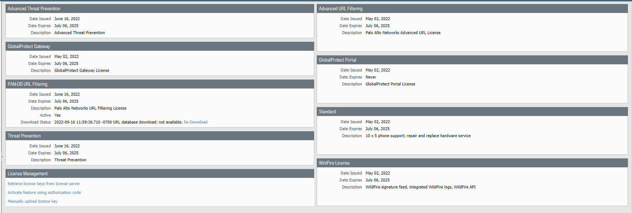

Step 1: Go to retrieve new licenses

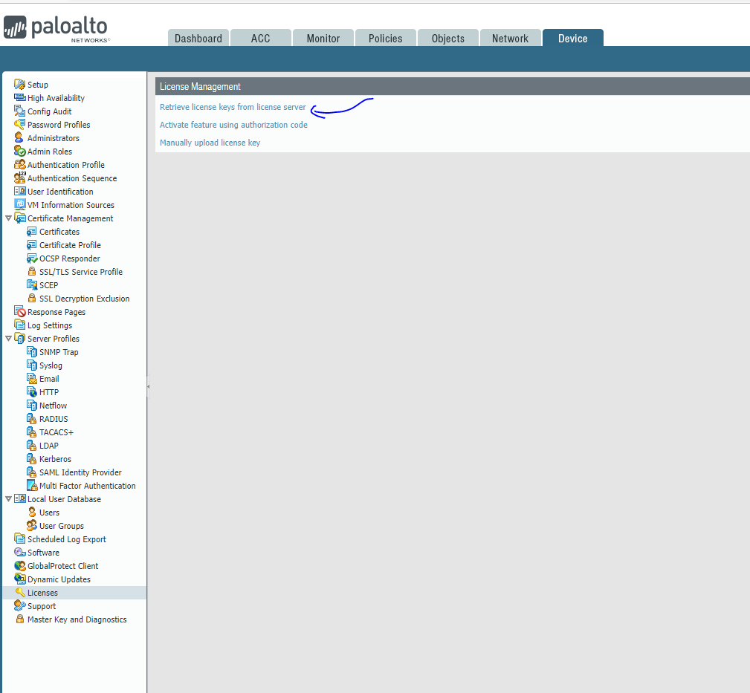

Step 2: Click Retrieve keys from license server

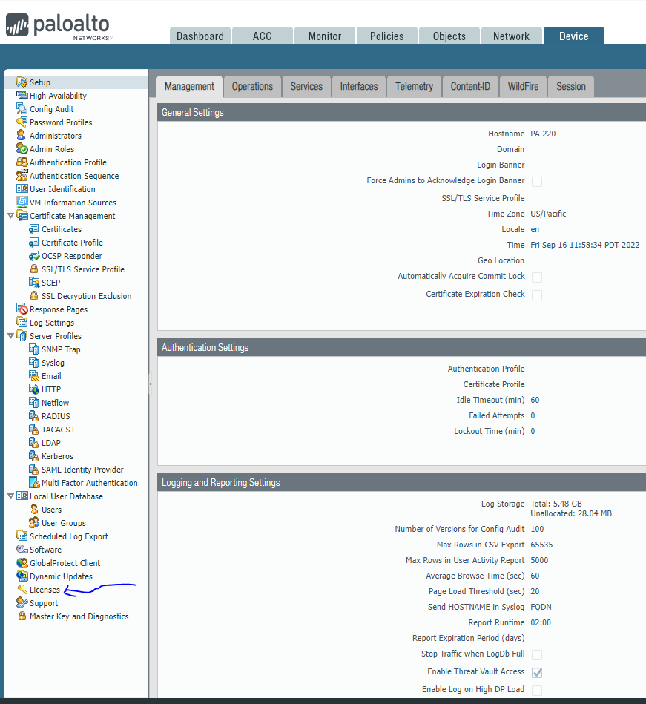

Step 3: Click Licenses

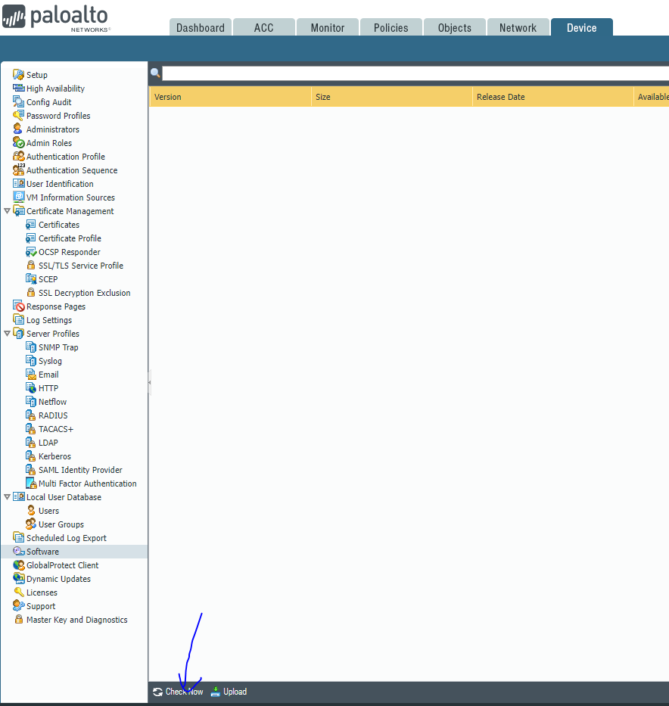

Step 4: Click check now for new versions that are available

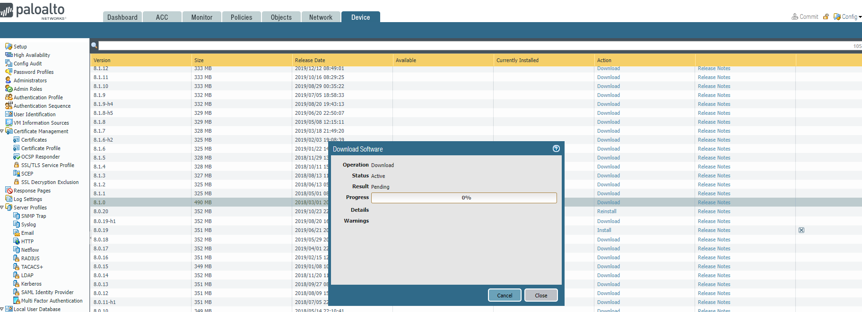

Step 5: Do something else while waiting for download.

Problems: We were having an error occur when we tried to fetch new licenses. This prevented us from doing any form of new software update. The solution was to find a DNS server from big tech that would start the updating process.

Conclusion: In the end, since our journey to the latest version was pretty short, we did not have many problems.